NBKRIST

POWER ELECTRONICS LECTURE NOTES
UNIT-5
I.PRABHAKAR REDDY & G.VIJAYKRISHNA
DEPARTMENT OF ELECTRICAL AND ELECTRONICS ENGINEERING

AC VOLTAGE CONTROLLERS
5.1 Introduction
AC voltage controller is a type of thyristor power converter which is used to convert a fixed voltage AC input supply to obtain a variable voltage AC output with constant frequency as shown in fig 5.1. The RMS value of the ac output voltage and the ac power flow to the load is controlled by varying (adjusting) the trigger angle ‘α’
Fig :5.1 basic block diagram

There are two different types of thyristor control used in practice to control the ac power flow
- On-Off control
- Phase control
5.1.1 ON-OFF CONTROL
In On-Off control technique Thyristors are used as switches to connect the load circuit to the ac supply (source) for a few cycles of the input ac supply and then to disconnect it for few input cycles. The Thyristors thus act as a high speed contactor (or high speed ac switch).
5.1.2 PHASE CONTROL
In phase control the Thyristors are used as switches to connect the load circuit to the input ac supply, for a part of every input cycle. That is the ac supply voltage is chopped using Thyristors during a part of each input cycle. By controlling the phase angle or the trigger angle ‘α’ (delay angle), the output RMS voltage across the load can be controlled. The trigger delay angle ‘α’ is defined as the phase angle (the value of ωt) at which the thyristor turns on and the load current begins to flow.
Thyristors in ac voltage controllers are line commutated (phase commutated or naturally commutated) since the input supply is ac. When the input ac voltage reverses and becomes negative during the negative half cycle the current flowing through the conducting thyristor decreases and falls to zero. Thus the ON thyristor naturally turns off, when the device current falls to zero.
Phase controls Thyristors which are relatively inexpensive, converter grade Thyristors which are slower than fast switching inverter grade Thyristors are normally used.
For applications up to 400Hz, if TRIAC’s are available to meet the voltage and current ratings of a particular application, TRIAC’s are more commonly used. Due to ac line commutation or natural commutation, there is no need of extra commutation circuitry or components and the circuits for ac voltage controllers are very simple.
5.1.3 TYPE OF AC VOLTAGE CONTROLLERS
The ac voltage controllers are classified into two types based on the type of input ac supply applied to the circuit.
- Single Phase AC Controllers.
- Three Phase AC Controllers.
Single phase ac controllers operate with single phase ac supply voltage of 230V RMS at 50Hz in our country. Three phase ac controllers operate with 3 phase ac supply of 400V RMS at 50Hz supply frequency.
Each type of controller may be sub divided into
- Uni-directional or half wave ac controller.
- Bi-directional or full wave ac controller.
In brief different types of ac voltage controllers are
- Single phase half wave ac voltage controller (uni-directional controller).
- Single phase full wave ac voltage controller (bi-directional controller).
- Three phase half wave ac voltage controller (uni-directional controller).
- Three phase full wave ac voltage controller (bi-directional controller).
5.1.4 APPLICATIONS OF AC VOLTAGE CONTROLLERS
- Lighting / Illumination control in ac power circuits.
- Induction heating.
- Industrial heating & Domestic heating.
- Transformers tap changing (on load transformer tap changing).
- Speed control of induction motors (single phase and poly phase ac induction motor control).
- AC magnet controls.
5.2 Principle of On-Off Control Technique (Integral Cycle Control)
The basic principle of on-off control technique is explained with reference to a single phase full wave ac voltage controller circuit shown below figure 5.2. The thyristor switches and are turned on by applying appropriate gate trigger pulses to connect the input ac supply to the load for ‘n’ number of input cycles during the time interval . The thyristor switches and are turned off by blocking the gate trigger pulses for ‘m’ number of input cycles during the time interval. The ac controller ON time usually consists of an integral number of input cycles.
Thyristors are turned ON precisely at the zero voltage crossings of the input supply. The thyristor is turned on in positive half cycle and the thyristor is turned on in negative half cycle by applying gating signal to the gates of T₁ and, during in the respective half cycles. The load current flows during T_{ON} and it is in bi-directional (alternating load current flow).
This type of control is used in applications which have high mechanical inertia and high thermal time constant (Industrial heating and speed control of ac motors). Due to zero voltage and zero current switching of Thyristors, the harmonics generated by switching actions are reduced.
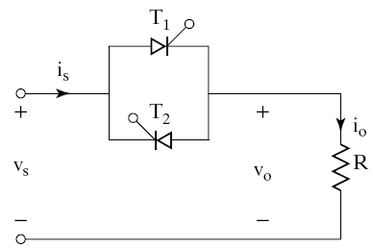
= Load Resistance
Fig:5.2 Single phase full wave AC voltage controller circuit
Example: Referring to the waveforms of ON-OFF control technique in the below diagram fig 5.3,
Two input cycles. Thyristors are turned ON during for two input cycles.
One input cycle. Thyristors are turned OFF during for one input cycle
For a sine wave input supply voltage,
RMS value of input ac supply = = RMS phase supply voltage.
If the input ac supply is connected to load for ‘n’ number of input cycles and disconnected for ‘m’ number of input cycles, then
Where = input cycle time (time period) and
= input supply frequency.
= controller on time =; = controller off time =.
= Output time period =.
We can show that,
Output RMS voltage
Where the RMS is input supply voltage =.

Fig.: 5.3 Waveforms of On-Off Control
5.2.1 To Derive An Expression For The Rms Value Of Output Voltage, For On-Off Control Method.
Output RMS voltage
Substituting for
Now = An integral number of input cycles; Hence
&
Where T is the input supply time period (T = input cycle time period). Thus we note that
Where = RMS value of input supply voltage;
= duty cycle (d).
5.3 Performance Parameters of Ac Voltage Controllers
- RMS Output (Load) Voltage
Where = RMS value of input supply voltage.
- Duty Cycle
Where, = duty cycle (d).
- RMS Load Current
; for a resistive load .
- Output AC (Load) Power
- Input Power Factor
; RMS input supply current.
The input supply current is same as the load current
Hence, RMS supply current = RMS load current; .
- The Average Current of Thyristor
Average thyristor current is shown in below figure 5.4
Fig 5.4 Average current of thyristor
=>
=>
=>
=>
, Where = maximum or peak thyristor current.
- RMS Current of Thyristor
=>
=>
=>

5.5 Single phase full wave AC voltage controller with resistive load:
- Single phase full wave ac voltage controller circuit using two SCRs or a single triac is generally used in most of the ac control applications. A single phase full wave ac voltage controller with a resistive load is shown in the figure 5.5 below. It is possible to control the ac power flow to the load in both the half cycles by adjusting the trigger angle α. Hence the full wave ac voltage controller is also referred to as to a bi-directional controller.
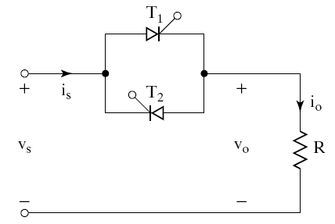
Fig 5.5 Single phase full wave ac voltage controller circuit using two SCR’s

- The thyristor T₁ is forward biased during the positive half cycle of the input supply voltage. The thyristor T₁ is triggered at a delay angle of α. Considering the on thyristor T₁ as an ideal closed switch the input supply voltage appears across the load resistor R and the output voltage, v_{O} is same as input voltage, v_{S} during ωt = α to π radians. The load current flows through the conducting thyristor T₁ and through the load resistor R in the downward direction in this period. At ωt = π, when the input voltage falls to zero the thyristor current falls to zero and hence T₁ naturally turns off. No current flows in the circuit during ωt = π to (π+ α).
- The thyristor T₂ is forward biased during the negative cycle of input supply and when thyristor T₂ is triggered at a delay angle (π+ α), the output voltage follows the negative half cycle of input from ωt = (π+ α) to 2π. When T₂ is on, the load current flows in the reverse direction (upward direction). The time interval between the gate trigger pulses of T₁ and T₂ is kept at π radians. At ωt = 2π the input supply voltage falls to zero and hence the load current also falls to zero and thyristor T₂ turns off naturally. Respective waveforms are shown in figure 5.7 .
- Instead of using two SCR’s in parallel, a Triac can be used for full wave ac voltage control as shown in figure 5.6.
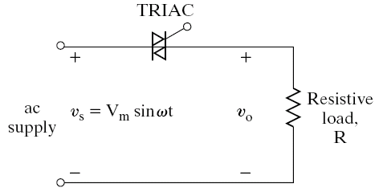
Fig 5.6: Single phase full wave ac voltage controller circuit using TRIAC
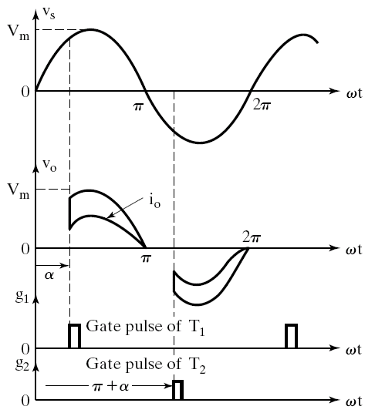
Fig 5.7 out put voltage waveforms

- For a sine wave input supply voltage,
Where V_{S} = RMS value of input ac supply = V_{m}/√2 = RMS phase supply voltage,
- Output load voltage is given by

5.5.1 Control Characteristic of Single Phase Full-Wave AC Voltage Controller with Resistive Load
The control characteristic is the plot of RMS output voltage versus the trigger angle; which can be obtained by using the expression for the RMS output voltage of a full-wave ac controller with resistive load.
; Where RMS value of input supply voltage
Fig 5.8 control characteristics
We can notice from the figure, that we obtain a much better output control characteristic by using a single phase full wave ac voltage controller. The RMS output voltage can be varied from a maximum of 100% at to a minimum of ‘0’ at . Thus we get a full range output voltage control by using a single phase full wave ac voltage controller.

5.6 Single phase full wave AC voltage controller with R-L load:
- In practice most of the loads are of RL type. For example a single phase full wave ac voltage controller controlling the speed of a single phase ac induction motor, the load which is the induction motor winding is an RL type of load, where R represents the motor winding resistance and L represents the motor winding inductance.
- A single phase full wave ac voltage controller circuit with an RL load using two thyristors T₁ and T₂ connected in parallel is shown in the figure below.
- The thyristor T₁ is forward biased during the positive half cycle of input supply. The thyristor T₁ is triggered at a delay angle of α, by applying a suitable gate trigger pulse to T₁ when is forward biased. The output voltage across the load follows the input supply voltage when T₁ is on. The load current flows through the load in the downward direction. This load current pulse flowing through T₁ can be considered as the positive current pulse. Due to the inductance in the load, the load current flowing through T₁ would not fall to zero at ωt = π, when the input supply voltage starts to become negative.
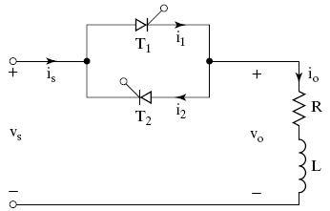
Fig 5.9 Single phase full wave ac voltage controller with RL load

- The thyristor T₁ will continue to conduct the load current until all the inductive energy stored in the load inductor L is completely utilized and the load current through T₁ falls to zero at ωt = β, where β is called as the extinction angle, at which the load current falls to zero. The thyristor T₁ conducts from ωt = α to β. Waveforms of single phase full wave ac voltage controller with RL load for α>ø are shown in the figures below. Discontinuous load current operation occurs for α>ø and β < (π+α).
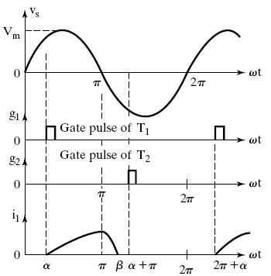

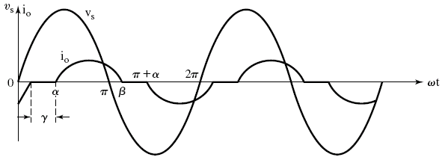

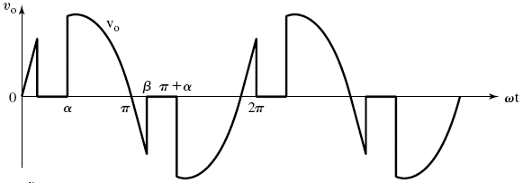
Fig 5.10 Single phase full wave ac voltage controller with RL load waveforms

- For a sine wave input supply voltage,
Where V_{S} = RMS value of input ac supply = V_{m}/√2 = RMS phase supply voltage,

- Output load voltage is given by

- This circuit, AC voltage controller can be used to regulate the RMS voltage across the terminals of an ac motor. It can be used to control the temperature of a furnace by varying the RMS output voltage.
- For very large load inductance ‘L’ the SCR may fail to commutate, after it is triggered and the load voltage will be a full sine wave (similar to the applied input supply voltage and the output control will be lost) as long as the gating signals are applied to the thyristors T₁ and T₂. The load current waveform will appear as a full continuous sine wave and the load current waveform lags behind the output sine wave by the load power factor angle φ as shown in figure 5.11.

Fig 5.11 load current waveforms if L is large

